**FAUVISM:**

Fauvism is of les Fauves, a French word which means "the wild beasts", a bunch of early 20th-century modern artists whose works emphasized painterly qualities and robust color over the representational or realistic values retained by Impressionism. Fauvism as a style started around 1904 and continued further than 1910, the movement intrinsically lasted only a couple of years, 1905–1908, and had three exhibitionsc

Fauvism is a style of painting that grew in France around 20th century. Artists of this movement used pure, luminous color aggressively applied straight from the paint tubes to create a sense of an explosion on the canvas. Spanning only a short time, Fauvism was known by its bold and expressive use of color and use of simple shapes.

**HENRI MATISSE:**

Henri Matisse was from France who was a painter, draughtsman, printmaker, and sculptor. He was the leader of the Fauvist movement, and he pursued the self-expression of color throughout his career. Matisse was often regarded as the most important French painter of the 20th century. Fauvism was too undisciplined to last long, and shortly its adherents were moving, consistent with their temperaments, toward Expressionism, Cubism, or some quite neo-traditionalism. Matisse had no liking for these directions, and if “Fauve” is taken to mean simply a painter with a passion for pure color, he are often said to possess remained one all his life.

**Paintings of Henri Matisse:**

Following are the paintings made by Henri Matisse for Fauvism.

**The Portrait of Madame Matisse (The Green Stripe):**

 Henri Matisse's Portrait of Madame Matisse (The Green Stripe) is a vibrant and graphic piece of art built upon the previous work of the Impressionists and Post- Impressionists and helped form a new movement, Fauvism. This painting was painted in 1905. Portrait of Madame Matisse (The Green Stripe) serves to illustrate the main stylistic hallmarks of the Fauvist movement even as it works to separate itself from the scholastic stylings of the past.

This is a portrait of Matisse’s wife. The painting focuses on her face which is placed at the center of the composition. With cropping that is suggestive of the Impressionist and photographic works which emerged onto the art scene years earlier, Portrait of Madame Matisse (The Green Stripe) creates its tension through the trimming of space surrounding Madame Matisse. She dominates the whole frame, physically touching all sides, from the top of her hair to her shoulders and lower chest. Like the Post-Impressionist Paul Cézanne, Matisse presses his subject close to the picture plane, almost into the viewer's space, in order to create a dynamic dialogue between the perceived dimensionality of Madame Matisse's figure and the flat surface of the painting. This emphasis on the two dimensional carries over into Matisse's portrayal of form. The way Matisse has sectioned the paint, it creates a three dimensional look. Matisse uses impasto brushstrokes to help flush out his forms, curving them over the shifting planes of Madame Matisse's face - creating curved strokes that inform the viewer as to its shape.  
  
Henri Matisse uses color in a very expressive manner. The color palette of Madame Matisse (The Green Stripe) is daring, saturated, unnatural and expressive. Matisse also included adjacent complimentary colors within his work which served to heighten the vibrancy, just as the competing sections of reds and greens in Portrait of Madame Matisse (The Green Stripe) stand out to the viewer's eye in a method of optical mixing. The overt green of the background balanced and highlighted the red of the dress, while the lighter green tint, which shapes the left side of Madame Matisse's face, pushes itself forward from the saturated red orange of the background. The juxtaposition of these two colors is a once jarring, yet innately pleasing, as they push the intensity of the color and bring vibrancy to Madame Matisse.

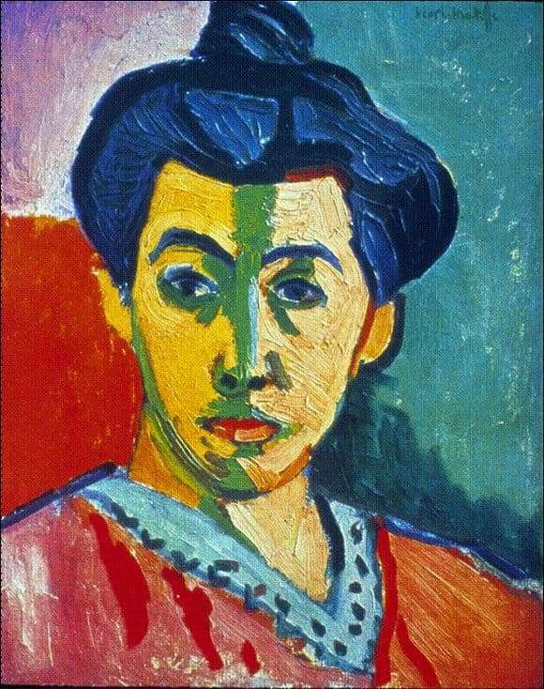

**Woman with a Hat (Femme au chapeau):**

Femme au chapeau marked a stylistic change from the regulated brushstrokes of Matisse's earlier work to a more expressive individual style. His use of not so natural colors and loose brushwork, which contributed to a sketchy or "unfinished" quality, seemed shocking to the viewers of the day.  
  
The artist's wife, Amélie, posed for this half-length portrait. She is depicted in an elaborate outfit with classic attributes of the French bourgeoisie: a gloved arm holding a fan and wearing an elaborate hat. Her costume's vibrant shades are purely expressive, however; when asked about the color of the dress Madame Matisse was actually wearing when she posed for the portrait, the artist supposedly replied, “Black, of course”

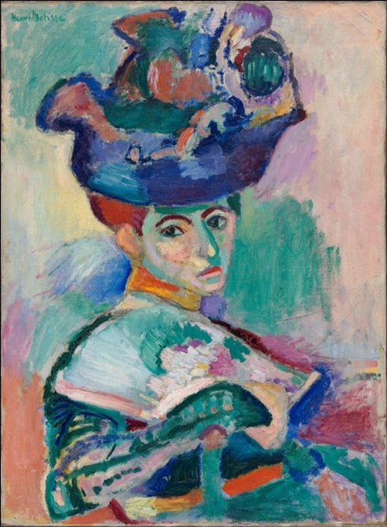

Matisse adds the maximum intensity of color, fundamentally eschewing chiaroscuro, the play of light and dark that creates an illusion of volume and spatial depth. Instead, the interior wall surrounding the window is equally divided into broad areas of blue-green and fuchsia, a contrast that is derived from the complementary opposition of green and red on the color wheel. In addition to that, Open Window also contains a dazzling variety of brushstrokes, from long blended marks to short, disconnected touches. Matisse represented each area of the image with a noticeably different handling of the brush, creating an overall surface effect of exciting cross-rhythms. Lastly, the composition of the work is a series of frames within frames: the wall contains the window; the window frames the middle ground; and the balcony crops the landscape.

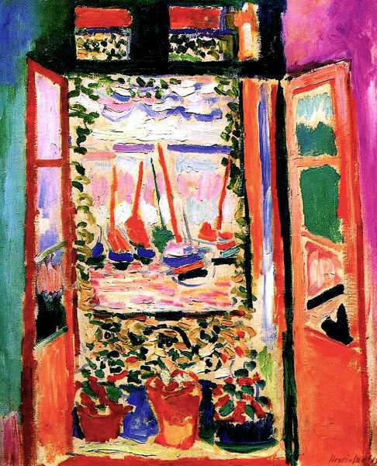

**ANDRE DERAIN:**

Andre Derain, other than being an excellent painter, was also an illustrator, set designer and sculptor. He was one of the famous painters of the Ecole de Paris; Andre Derain was a leading member of the short-lived colorist movement known as Fauvism. In 1905, Derain accompanied Matisse to the south of France. There in Collioure, both artists produced powerful canvases, applying bright, pure colours straight from the tube, and leaving whole areas of unprimed canvas bare. In these works they sought to express the simplicity and rawness of life in the Mediterranean, which was then a region still relatively untouched by outsiders.

Derain's fauvist paintings owe a considerable debt to both Paul Cezanne and Paul Gauguin, artists whose work Derain had seen in major shows in Paris.

**Paintings of Andre Derain:**

Following is the artwork made by Andre Derain for the Fauvism movement.

**The Dance:**

The Dance, representing an Arcadian landscape with dancing figures, is rooted in the classical primitive tradition. Derain began work on this painting after seeing a Gauguin retrospective. The influence of Gauguin's primitive oeuvre is seen plainly in the use of bold, flat colors, stylized elements (like the snake and the leaves), the choice to focus on an exotic landscape and the specific inclusion of a seated figure in the background almost identical to the one painted by Gauguin.

The artist purposefully removes his image from the recognizable world. The figures arms and legs are distorted and elongated. The artist emphasizes the rhythmic and sinuous lines of the overall anatomy in order to create a decorative pattern across the canvas. He uses unnatural colors to express primal emotions. Matisse's iconic Bonheur de Vivre (Joy of Life) (1905-06) exhibits interest in similar settings and took the stylistic idiom one step further, presenting an even more stripped down, and purer, version. The facial features, no doubt influenced by that African fang mask he owned, are equally unnatural and exaggerated. The figures dance before us in an uninhibited manner, in perfect ease to their surroundings. It's possible that Derain here develops the theme of fertility germane to Arcadia themes.

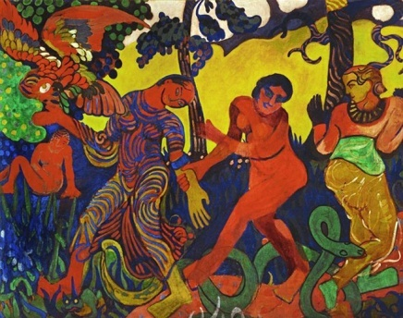

**Woman in a Chemise:**

Derain's ‘Woman in a Chemise’ shares a great deal with the Post-Impressionist interest in capturing a slice of modern life in Paris. Her pose, with crossed legs and upper body leaning forward, with that alluring and powerful gaze, raises the question of whether the figure was a dancer or actually something else entirely.

Derain's portrait is painted with extremely vibrant, unnatural colors. There is no traditional tone of light and shadow; instead he uses heavy outlines to bring volume and depth to the painting. The figure's facial features, arms, and legs are lengthened and there is an obvious simplification of delineation overall. The surface of the canvas is built up with thickly-applied patches of paint juxtaposed one beside the other, creating a vibrant, decorative effect.

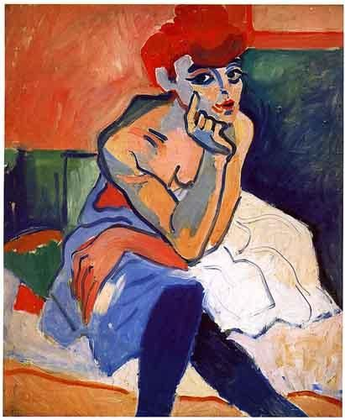

**The Houses of Parliament:**

The Houses of Parliament represents a Neo-Impressionist panoramic view of the Thames River in London. In this work Derain experimented with Divisionism, applying thick, similarly-shaped dabs of paint to the canvas in a methodical, even manner. The canvas is neatly divided into two sections, upper and lower section. The upper section which is devoted to the buildings and sky, is painted with vertical brushstrokes, while the bottom section which describes the water and the boat, is painted with horizontal ones. The artist uses a very bold color palette suggestive of Impressionist works throughout. The mosaics of strokes noted in the sky are reflected beneath in the water, creating an overall harmonious balance across the entire surface of the canvas.

